SQL Custom Queries for Polaris System Administrators

The Operators

= Equals > Greater than => Equal to/greater than
<> Does not equal < Less than <= Equal to/less than
NULL Unknown or non-existent value + Concatenate elements
* All fields % String of 0 or more characters _ Single character

The Simplest

QUERY: Show all fields of all bibliographic records

SELECT *
FROM Polaris.BibliographicRecords WITH (NOLOCK)

QUERY: Show all fields of all patron records

SELECT *
FROM Polaris.PatronRegistration WITH (NOLOCK)
Three Easy Pieces

QUERY: Show number of Item records in the Library's database

SELECT COUNT(*)
FROM Polaris.CircItemRecords WITH (NOLOCK)

QUERY: Show number of Bibliographic records in the Library's database

SELECT COUNT(*)
FROM Polaris.BibliographicRecords WITH (NOLOCK)

QUERY: Show number of Patron records in the Library's database

SELECT COUNT(*)
FROM Polaris.PatronRegistration WITH (NOLOCK)

Adding Another Field…
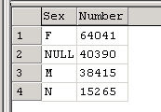
QUERY: Patron count by gender

SELECT Gender AS [Sex],
COUNT(*) AS [Number]
FROM Polaris.PatronRegistration WITH (NOLOCK)
GROUP BY Gender
ORDER BY Number DESC
… And Another Table
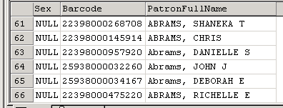
QUERY: Identify the NULLs (those with no Gender recorded)
with Barcodes, and sort by Last Name

SELECT PR.Gender AS Sex,
PT.Barcode,
PR.PatronFullName
FROM Polaris.PatronRegistration PR WITH (NOLOCK)
JOIN Patrons PT WITH (NOLOCK) ON PT.PatronID = PR.PatronID
WHERE PR.Gender IS NULL
ORDER BY NameLast

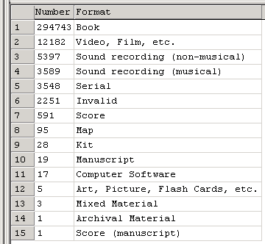
QUERY: Bib count by Type of Material,
sorted in descending order by number of items

SELECT COUNT(BR.PrimaryMARCTOMID) AS Number,
MT.Description AS 'Material Type'
FROM polaris.BibliographicRecords BR WITH (NOLOCK)
JOIN polaris.MARCTypeofMaterial MT ON
MT.MARCTypeofMaterialID = BR.PrimaryMARCTOMID
GROUP BY MT.Description
ORDER BY Number DESC

Finding the Empty Spaces…

QUERY: List all bibrecs that have NO attached items, and sort by Call Number for shelf check

SELECT BR.BibliographicRecordID AS [RecordID],
BR.BrowseCallNo AS [CallNo],
BR.BrowseAuthor + ' ' + BR.BrowseTitle AS [BibRec]
FROM Polaris.BibliographicRecords BR (NOLOCK)
WHERE BibliographicRecordID NOT IN
(SELECT DISTINCT AssociatedBibrecordID FROM polaris.CircItemRecords WITH (NOLOCK))
ORDER BY BR.BrowseCallNo

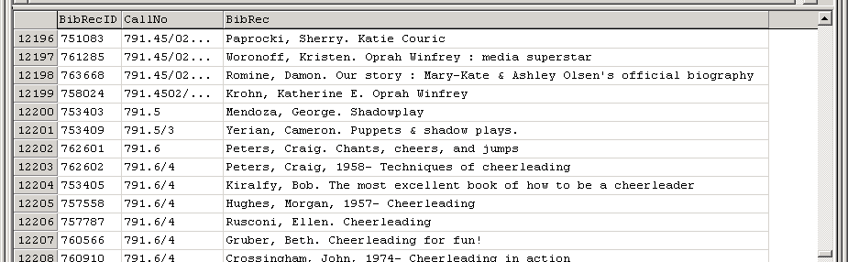
Extract from results:

(Query formatted for the Find Tool in SQL mode. Remove second and third lines.)
QUERY: Bibrecs without local call numbers (092 tag)

SELECT BibliographicRecordID AS ID,
BrowseAuthor AS Author,
BrowseTitle AS Title
FROM polaris.BibliographicRecords WITH (NOLOCK)
WHERE BibliographicRecordID NOT IN
(SELECT BibliographicRecordID
FROM Polaris.BibliographicTags WITH (NOLOCK)
WHERE TagNumber = 092)
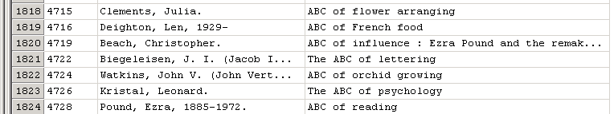

Extract from results:

…And the Particular Spaces

QUERY: Titles with Reference ('9') Items at a Particular Branch ('5')

SELECT BR.BrowseCallNo AS CallNo,
BR.BrowseAuthor + ' ' + BR.BrowseTitle AS BibRec
FROM BibliographicRecords BR WITH (NOLOCK)
JOIN CircItemRecords CIR WITH (NOLOCK) ON
CIR.AssociatedBibRecordID = BR.BibliographicRecordID
-- Name the collection
WHERE CIR.AssignedCollectionID = '9' AND
-- Name the owning branch
CIR.AssignedBranchID = '5'
ORDER BY BR.BrowseCallNo

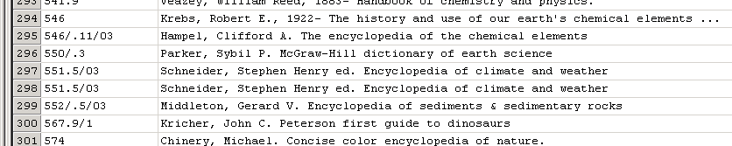
Extract from Results:

Some Frequently Asked Queries

QUERY: Number of holds per Bibrec

SELECT COUNT(SysHoldRequests) AS Holds,
Title
FROM Polaris.SysHoldRequests WITH (NOLOCK)
WHERE SysHoldStatusID <> 0
GROUP BY Title
ORDER BY Holds DESC

QUERY: Item Circulations for December by Stat Code (per HvanInwegen)

SELECT O.Name AS Branch,
SC.Description AS ItemStatCode,
COUNT(ItemRecordID) AS 'Count'
FROM Polaris.Organizations O WITH (NOLOCK)
JOIN PolarisTransactions..TransactionHeaders TH WITH (NOLOCK) ON
TH.OrganizationID = O.OrganizationID
JOIN PolarisTransactions..TransactionDetails TD WITH (NOLOCK) ON
TH.TransactionID = TD.TransactionID
JOIN CircItemRecords CIR WITH (NOLOCK) ON TD.numValue = CIR.ItemRecordID
JOIN StatisticalCodes SC WITH (NOLOCK) ON CIR.StatisticalCodeID = SC.StatisticalCodeID AND
CIR.AssignedBranchID = SC.OrganizationID
-- Look only for check-outs by item…
WHERE TH.TransactionTypeID = 6001 AND TD.TransactionSubTypeID = 38
-- …during a specified time-period
AND TH.TranClientDate BETWEEN '2009-12-01 00:00' AND '2009-12-31 23:59'
Group By O.Name, SC.Description
Order By O.Name, SC.Description

Extract from Results: Branch ItemStatCode Count
---------------------------------------------- ----------------------------------
Carnegie Public Library Audio Book 19
Carnegie Public Library Biography 1
Carnegie Public Library Fiction 19
Carnegie Public Library ILL 3
Carnegie Public Library Juvenile Fiction 17
Carnegie Public Library Juvenile Nonfiction 25

QUERY: Display 'Local' patrons (e.g., for Branch 5)

SELECT O.Name AS [Library],
P.Barcode,
PR.PatronFullName AS [Patron]
FROM polaris.Patrons P WITH (NOLOCK)
JOIN polaris.PatronRegistration PR WITH (NOLOCK) ON PR.PatronID = P.PatronID
JOIN polaris.Organizations O WITH (NOLOCK) ON O.OrganizationID = P.OrganizationID
-- Name the branch
WHERE P.OrganizationID = 5
ORDER BY PR.NameLast

Extract from Results:
…
Carnegie Public Library 21030722883073 ADAMS, BRIGID
Carnegie Public Library 21030722740018 ADAMS, CATHY
Carnegie Public Library 21030722765668 ADAMS, SUE M
Carnegie Public Library 21030722650035 ADAMS, PATRICK
Carnegie Public Library 21030722656875 ADAMS, EDWARD T
Carnegie Public Library 21030722793520 ADAMS, JONATHAN R
Carnegie Public Library 21030722623719 ADAMS, GRACE G
Carnegie Public Library 21030722863588 ADAMS, LEONARD B
…

NOTE: Other criteria may be used in the WHERE clause to limit the list further, for example:
…
WHERE P.OrganizationID = 5 AND
PR.NameLast LIKE 'A%' AND
PR.StatisticalClass = '01225' AND
PR.EntryDate BETWEEN '2005-01-01' AND '2005-12-31'

NOTE

The LIKE operator allows specified string patterns to be matched in a query. The pattern can include special 'wildcard' characters such as:

% Any string of 0 or more characters in position, such as '%ville%', with '…ville…' anywhere in the matching record

[ ] Characters specified in this position only (used with var and varchar fields). Thus,
'[CK]ath[yi]' finds 'Kathy' as well as 'Cathy', and 'Kathi' as well as 'Cathi'

[ ^ ] The match will NOT have this character. Thus, '[A-Z^L]ars[eo]n' finds any name ending in '…arson' or '…arsen' except 'Larson' and 'Larsen'

_ (underscore) Single character, so '_heryl' finds both 'Sheryl' and 'Cheryl'

Four for CIRC…

QUERY: Find the most popular titles in the collection (i.e., most frequently borrowed of late)

SELECT BR.BrowseCallNo AS [CallNumber],
BR.BrowseTitle AS [Title],
CIR.YTDCircCount AS [Count]
FROM polaris.BibliographicRecords BR WITH (NOLOCK)
JOIN polaris.CircItemRecords CIR WITH (NOLOCK) ON
CIR.AssociatedBibRecordID = BR.BibliographicRecordID
WHERE CIR.YTDCircCount > 25
ORDER BY Count

Extract from Results:
NULL Dr. Strangelove; or, How I learned to stop worrying and love the bomb [videorecording] 11
NULL Love you to bits and pieces : life with David Helfgott 11
NULL Notes from a sea diary: Hemingway all the way. 12
NULL Pathfinder : [sound recording] : first in, last out 12
NULL Nothing is impossible [sound recording] : reflections on a new life 12
364.1 RULE Last dance, last chance : and other true cases 12
NULL The case of the psychic's vision 13
NULL Sandy Koufax [sound recording] : [a lefty's legacy] 13
NULL Snake 13
796/.092 B Jim Thorpe : discover the life of an American legend 14
NULL Serendipity [videorecording] 15

And, by contrast…

QUERY: Find the Shelf-Sitters (i.e., NO circs within the last several years)

SELECT TOP 5
CONVERT(varchar, CIR.LastCircTransactionDate, 101) AS LastCircDate,
BR.BrowseCallNo AS CallNo,
BR.BrowseTitle AS Title
FROM polaris.BibliographicRecords BR WITH (NOLOCK)
JOIN polaris.CircItemrecords CIR WITH (NOLOCK) ON
CIR.AssociatedBibRecordID = BR.BibliographicRecordID
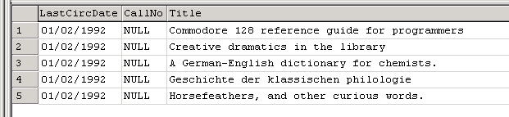
WHERE CIR.LastCircTransactionDate < '2007-01-01'
ORDER BY LastCircDate, CallNo

NOTE: In the CONVERT statement, '101' is the style of date shown in the results set. Style '1' has
the form '01/02/99'. Several supported Date types are shown in SQLBooksOnline (Help), under 'CONVERT'.

QUERY: Find the busiest patron (i.e., the one with the most circs to date)

SELECT TOP 10
P.LifetimeCircCount AS [#Circs],
PR.PatronFullName AS [Patron],
PR.PhoneVoice1 AS [TelNo]
FROM polaris.PatronRegistration PR WITH (NOLOCK)
JOIN polaris.Patrons P WITH (NOLOCK) ON P.PatronID = PR.PatronID
WHERE P.LifetimeCircCount > 200
ORDER BY #Circs DESC

NOTE: Often a 'pseudo-patron' (such as 'ILL', or a nursing home) will have the most. Exclude them with a 'BETWEEN…' clause in
the WHERE statement, such as '…BETWEEN 200 AND 2000' instead of ' >200'

QUERY: Find all items with the status of 'LOST'

SELECT BR.BrowseCallNo AS [CallNumber],
BR.BrowseTitle AS [Title]
FROM polaris.BibliographicRecords BR WITH (NOLOCK)
JOIN polaris.CircItemRecords CIR WITH (NOLOCK) ON CIR.AssociatedBibRecordID = BR.BibliographicRecordID
JOIN polaris.ItemStatuses IST WITH (NOLOCK) ON IS.ItemStatusID = CIR.ItemStatusID
WHERE IST.Description = 'Lost'
ORDER BY CallNumber

…And Two for Cataloging

QUERY: Count items added to the database each month during 2005, by Format

SELECT DATEPART(mm,IRD.CreationDate) AS [Month],
COUNT(CASE BR.FormatID WHEN 1 THEN 0 ELSE NULL END) AS [Books],
COUNT(CASE BR.FormatID WHEN 2 THEN 0 ELSE NULL END) AS [Magazines],
COUNT(CASE BR.FormatID WHEN 7 THEN 0 ELSE NULL END) AS [Videos],
COUNT(CASE BR.FormatID WHEN 8 THEN 0 ELSE NULL END) AS [Audios],
COUNT(CASE BR.FormatID WHEN 9 THEN 0 ELSE NULL END) AS [CDs]
FROM polaris.ItemRecordDetails IRD WITH (NOLOCK)
JOIN polaris.CircItemRecords CIR WITH (NOLOCK) ON CIR.ItemRecordID = IRD.ItemRecordID
JOIN polaris.BibliographicRecords BR WITH (NOLOCK) ON
BR.BibliographicrecordID = CIR.AssociatedBibRecordID
WHERE IRD.CreationDate BETWEEN '2009-01-01' AND '2009-12-31'
GROUP BY MONTH(IRD.CreationDate)
ORDER BY MONTH(IRD.CreationDate)

Extract from Results:
Month Books Magazines Videos Audios CDs
----------- ----------- ----------- ----------- ----------- -----------
1 77 15 3 0 0
2 65 11 0 1 0
3 19 0 1 1 0
4 109 5 5 2 1
5 78 6 1 0 1
…

Note: Use a look-up query to determine your specific format codes

SELECT * FROM Polaris.Formats

Extract from Results:
FmtID Description SearchCode
-------- -------------------------------------------------------------------
1 Book bk
2 Serial ser
3 Score sco
4 Score (manuscript) scom
5 Map map
6 Map (manuscript) mapm
7 Video, Film, etc. vid
…

QUERY: Identify all 'S' Author Authority Records added in 2009

SELECT TOP 15
CONVERT(varchar, AR.FirstUseDate, 101) AS [DateUsed],
MAH.BrowseAuthor AS [Heading]
FROM polaris.AuthorityRecords AR WITH (NOLOCK)
JOIN polaris.AuthorityHeadingIndices AHI WITH (NOLOCK) ON AHI.AuthorityRecordID = AR.AuthorityRecordID
JOIN polaris.MainAuthorHeadings MAH WITH (NOLOCK) ON
MAH.MainAuthorHeadingID = AR.MainAuthorHeadingID
WHERE AR.FirstUseDate BETWEEN '2009-01-01' AND '2009-12-31' AND
MAH.BrowseAuthor LIKE 'S%'
ORDER BY Heading

Extract from Results:
Date Heading
------------------------------ ------------------------------
08/23/2005 Saban Entertainment
07/01/2005 Sacani, Christine
07/06/2005 Sachs, Albie, 1933-
…

From the Transactions Database

QUERY: Determine all TransactionTypes and SubTypes from PolarisTransactions DB

SELECT * FROM polarisTransactions.ViewTransactions

QUERY: Count Check-outs by Branch during 2009

SELECT COUNT(TH.TransactionID) AS [Circs], O.Name AS [Library]
FROM polarisTransactions.TransactionHeaders TH WITH (NOLOCK)
JOIN polarisTransactions.TransactionDetails TD WITH (NOLOCK) ON
TD.TransactionID = TH.TransactionID
JOIN polaris.Organizations O WITH (NOLOCK) ON O.OrganizationID = TH.OrganizationID
WHERE TH.TransactionTypeID = 6001 AND
TD.TransactionSubTypeID = 145 AND
TD.TransactionDate BETWEEN '2009-01-01' AND '2009-12-31'
GROUP BY Library
ORDER BY Library

Extract from Results: Circs Library
----------- ------------------------------------
27 Bryant Library
1761 Carnegie Public Library
576 Harlingen Public Library
3 Library
517 Main Branch A
…
QUERY: Determine YTD Check-outs by Branch from the Aggregates tables

SELECT COUNT(AggregateTypeID) AS Circs, O.Name AS Library
FROM polarisTransactions..Aggregates AG WITH (NOLOCK)
JOIN polaris..Organizations O WITH (NOLOCK) ON O.OrganizationID = AG.OrganizationID
WHERE AggregateTypeID = 10 AND StartDateTime > '2009-01-01'
GROUP BY O.Name

QUERY: Circulation by Item Stat Code, Branch and Date

SELECT O.Name AS [Branch],
SC.Description AS [ItemStatCode],
COUNT(ItemRecordID) AS [Count]
FROM polaris.Organizations O WITH (NOLOCK)
JOIN polarisTransactions..TransactionHeaders TH WITH (NOLOCK) ON
O.OrganizationID = TH.OrganizationID
JOIN polarisTransactions..TransactionDetails TD WITH (NOLOCK) ON
TH.TransactionID = TD.TransactionID
JOIN polaris.CircItemRecords CIR WITH (NOLOCK) ON CIR.ItemRecordID = TD.numValue
JOIN polaris.StatisticalCodes SC WITH (NOLOCK) ON CIR.StatisticalCodeID = SC.StatisticalCodeID AND CIR.AssignedBranchID = SC.OrganizationID
WHERE TH.TransactionTypeID = 6001 AND
TH.TransactionDate BETWEEN '2009-01-01 12:02:00' AND '2009-12-31 23:59:00'
GROUP BY O.Name, SC.Description
ORDER BY O.Name, SC.Description

Extract from Results:
…
Carnegie Public Library Audio Book 183
Carnegie Public Library Biography 3
Carnegie Public Library Fiction 799
Carnegie Public Library ILL 8
Carnegie Public Library Juvenile Fiction 118
Carnegie Public Library Juvenile Nonfiction 217
Carnegie Public Library Magazine 1
Carnegie Public Library Movie 138
Carnegie Public Library Music 44
Carnegie Public Library Mystery 7
Carnegie Public Library Nonfiction 3965
…

A slightly different take on the same query (from HVI; note comments)

SELECT O.Name AS [Branch],
SC.Description AS [ItemStatCode],
COUNT(ItemRecordID) AS [COUNT]
FROM polaris.Organizations O WITH (NOLOCK)
-- Reach into the transactions database for the specific checkout activity;
-- Note the two periods between database name and table name
JOIN polarisTransactions..TransactionHeaders TH WITH (NOLOCK) ON
TH.OrganizationID = O.OrganizationID
JOIN polarisTransactions..TransactionDetails TD WITH (NOLOCK) ON
TH.TransactionID = TD.TransactionID
--Table CIR is in the same DB (polaris) as the primary table
JOIN polaris.CircItemRecords CIR WITH (NOLOCK) ON TD.numValue = CIR.ItemRecordID
-- Join the SC table on two elements for accuracy
JOIN polaris.StatisticalCodes SC WITH (NOLOCK) ON
CIR.StatisticalCodeID = SC.StatisticalCodeID AND
CIR.AssignedBranchID = SC.OrganizationID
-- Declare the date-range here; set TransType = 6001 (Check-out) and SubType = 38 (Item)
WHERE TH.TransactionTypeID = 6001 AND TD.TransactionSubTypeID = 38 AND
TH.TranClientDate between '2009-12-01 00:00:01.000' and '2009-12-31 11:59:59.000'
GROUP BY O.Name, SC.Description
ORDER BY O.Name, SC.Description

Sample TransactionTypes: Sample TxnSubTypes:
2001 Patron reg created 4 Material Type
3003 Bib record created 6 PatronID
3008 Item record created 7 Patron Code
6001 Check out 33 PatronStatClassCode
6002 Check in 36 BibRecord ID
6005 Hold created 38 ItemRecordID
6006 Hold becomes held 45 ISBN
6013 Hold becomes cancelled 49 Title
6015 Patron accounting – charge 58 Assigned Branch ID
5009 PO created 97 PO Line Item ID
5010 PO released 123 Patron Assigned Branch ID

SQL Guides

1. Bowman, Judith et al. The practical SQL handbook. 3d ed. ISBN 0201447878 454p.

2. Celko, Joe Joe Celko's SQL for smarties. 2d ed. ISBN 1558605762 576p.

3. Forta, Ben SAMS teach yourself SQL in 10 minutes. ISBN 0672321289 272p.

4. Groff, James R. SQL the complete reference. ISBN 0072118458 1008p.

5. Henderson, Ken The Guru's guide to Transact-SQL. ISBN 0201615762 592p.

6. Viescas, John SQL queries for mere mortals. ISBN 0201433362 528p.

7. Houlette, Forrest SQL: a beginner's guide. ISBN 0072130962 424p.

8. Kline, Kevin E. SQL in a nutshell. 4th ed. ISBN 1565927443 224p.

9. Rankins, Ray et al. MS SQL Server unleashed. ISBN 0672312977 1512p.

10. Taylor, Allen G. SQL for dummies. 4th ed. ISBN 0764507370 440p.

